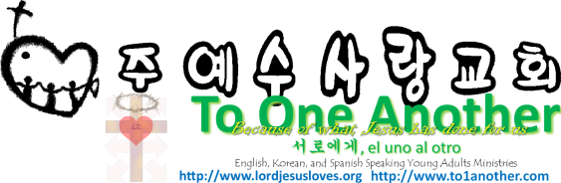
The Laws of Moses
Pastor Yoo Nam Kang
Romans 3:20
Scriptures in New Living Translation
August 26, 2012
Romans 3:20
For no one can ever be made right with God by doing what the law commands. The law simply shows us how sinful we are.

- The First Covenant
Deuteronomy 5:1-3
1 Moses called all the people of Israel together and said, “Listen carefully, Israel. Hear the decrees and regulations I am giving you today, so you may learn them and obey them! 2 “The Lord our God made a covenant with us at Mount Sinai. 3 The Lord did not make this covenant with our ancestors, but with all of us who are alive today.
Galatians 3:19
Why, then, was the law given? It was given alongside the promise to show people their sins. But the law was designed to last only until the coming of the child who was promised. God gave his law through angels to Moses, who was the mediator between God and the people.

- What was the purpose of the law then?
Romans 3:20
For no one can ever be made right with God by doing what the law commands. The law simply shows us how sinful we are.
1Corinthians 15:56
For sin is the sting that results in death, and the law gives sin its power.

- What are the results of living a life following the law?
Romans 4:15
For the law always brings punishment on those who try to obey it. (The only way to avoid breaking the law is to have no law to break!)
Galatians 5:4
For if you are trying to make yourselves right with God by keeping the law, you have been cut off from Christ! You have fallen away from God’s grace.
Hebrews 10:9-10
9 Then he said, “Look, I have come to do your will.” He cancels the first covenant in order to put the second into effect. 10 For God’s will was for us to be made holy by the sacrifice of the body of Jesus Christ, once for all time.
Philippians 3:7-9
7 I once thought these things were valuable, but now I consider them worthless because of what Christ has done. 8 Yes, everything else is worthless when compared with the infinite value of knowing Christ Jesus my Lord. For his sake I have discarded everything else, counting it all as garbage, so that I could gain Christ 9 and become one with him. I no longer count on my own righteousness through obeying the law; rather, I become righteous through faith in Christ. For God’s way of making us right with himself depends on faith.
Matthew 5:17
Don’t misunderstand why I have come. I did not come to abolish the law of Moses or the writings of the prophets. No, I came to accomplish their purpose.
Luke 16:16
Until John the Baptist, the law of Moses and the messages of the prophets were your guides. But now the Good News of the Kingdom of God is preached, and everyone is eager to get in.

Hebrews 9:11-12
11 So Christ has now become the High Priest over all the good things that have come. He has entered that greater, more perfect Tabernacle in heaven, which was not made by human hands and is not part of this created world. 12 With his own blood—not the blood of goats and calves—he entered the Most Holy Place once for all time and secured our redemption forever.
John 10:27-30
27 My sheep listen to my voice; I know them, and they follow me. 28 I give them eternal life, and they will never perish. No one can snatch them away from me, 29 for my Father has given them to me, and he is more powerful than anyone else. No one can snatch them from the Father’s hand. 30 The Father and I are one
Luke 12:12
for the Holy Spirit will teach you at that time what needs to be said.”

